

LAB 08

Miss Ayesha Majid

Muhammad Abdullah

53457

## Creating Schema

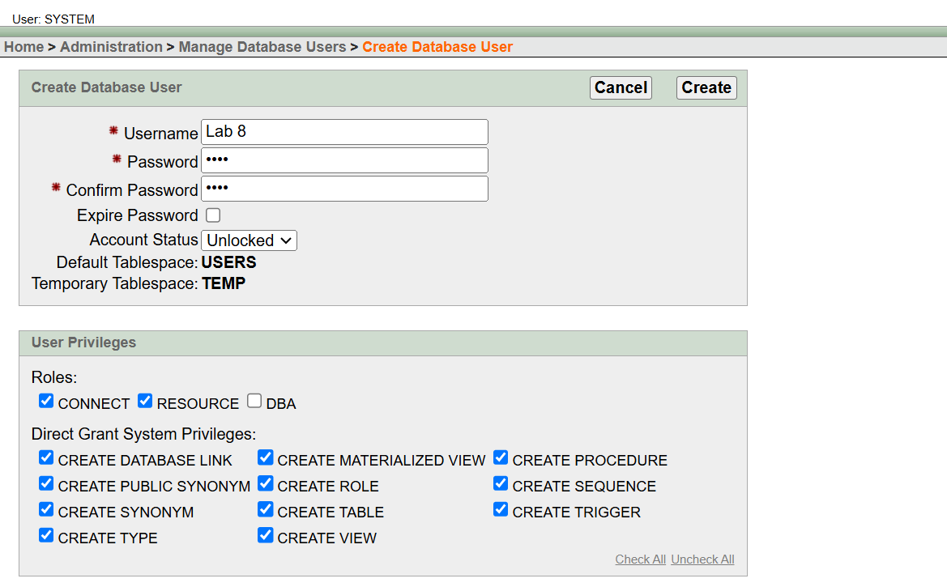

## Tables After Insertion

1. **Employee Table:**

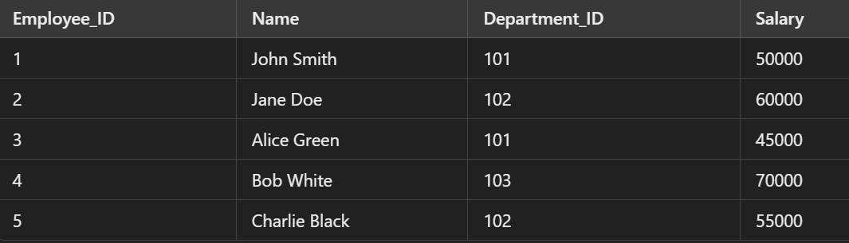

1. **Departments Table**

1. **Projects Table**

### Task 1

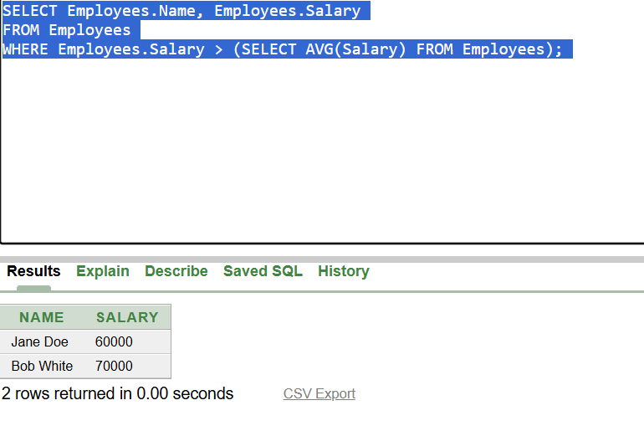

### Task 2

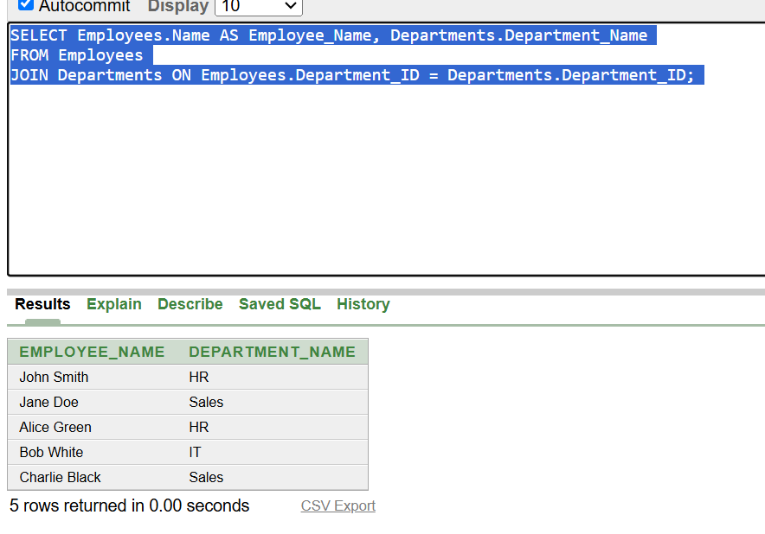

### Task 3

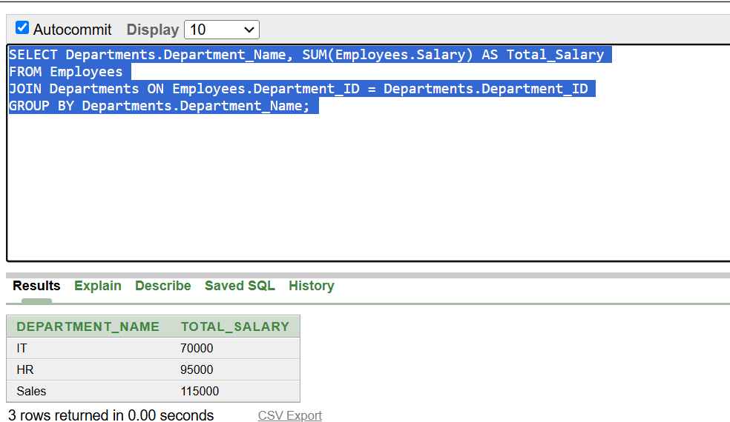

### Task 4

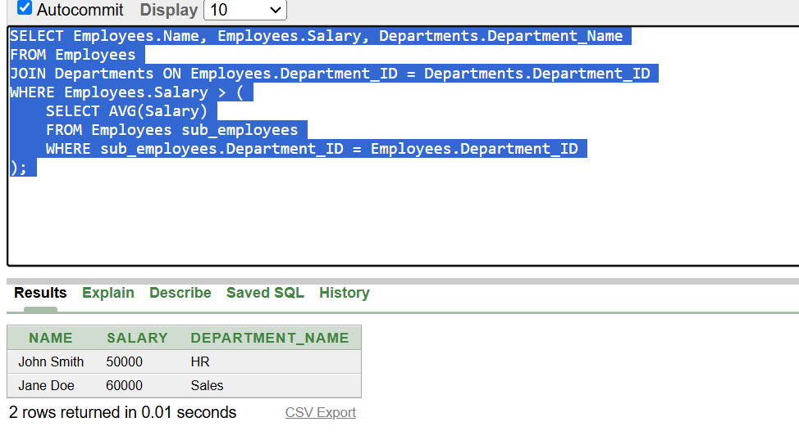

### Task 5

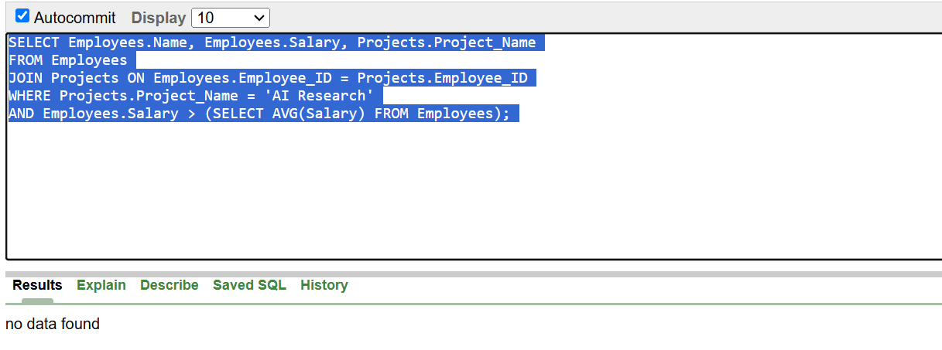

### Task 6

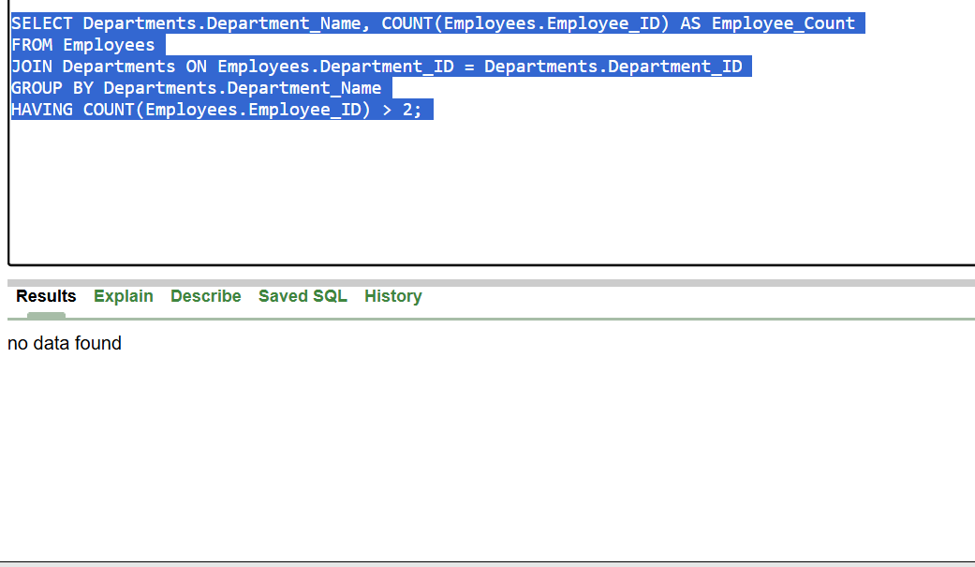

### Task 7

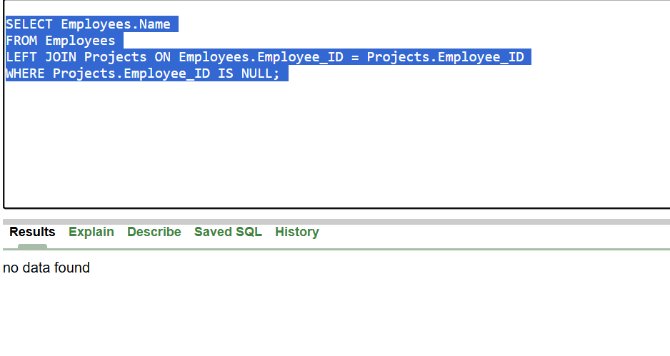

### Task 8

